DISSERTATION TEMPLATE FOR INTERNATION JOURNAL OF DESIGN SCIENCE

NAME ¹
NAME ²
¹ Organization, Country
² Organization, Country

Abstract: As an English-language academic publication, The International Journal of Design Science (IJDS) is quarterly published online at http://www.isds2006.com by the International Society for Design Science (ISDS). The editorial office is located in the United States, and the China branch is situated in the Shanghai representative office of the ISDS (Preparatory Office). Just as shown in the journal’s name, we try to explore science for better designs. We initiate a call for paper in all areas related to design, including research papers, survey papers, case studies and other high quality scholarly articles.
Keywords: keyword；International Journal of Design Science.

INTRODUCTION
The Oriental Design Forum initiated by Shanghai Jiao Tong University has been successfully held for four times. Since the first forum, scholars and designers from design circles at home and abroad have repeatedly given in-depth discussions on Oriental Design with rich content and diverse perspectives, and achieved remarkable results. Reviewing the topics most concerned by scholars in previous forums, keywords such as Oriental Design, Oriental Aesthetics and Contemporary Practice were frequently mentioned (Zhou, 2017). Those topics highlighted over the previous forums just reveal that the current design circles have been keenly aware of the new opportunities and challenges facing oriental design in the development of the world today, especially Chinese design.

TEXT ONE
The thesis is generally composed of title, text description, figure and table.
The thesis is generally composed of title, text description, figure and table.

Text One
The thesis is generally composed of title, text description, figure and table.
Table 1. Table
 | Connectivity | Selectivity | Order | Quantity
Location | + | — | — | —
Shape | + | — | — | —
Orientation | + | 0 | — | —
Color | + | ++ | — | —
Texture | 0 | + | 0 | —
Gray scale | — | + | ++ | —
Size | — | + | + | +
Note: ++excellent; +good; 0 medium; —poor
The thesis is generally composed of title, text description, figure and table.

Text Two
The thesis is generally composed of title, text description, figure and table.
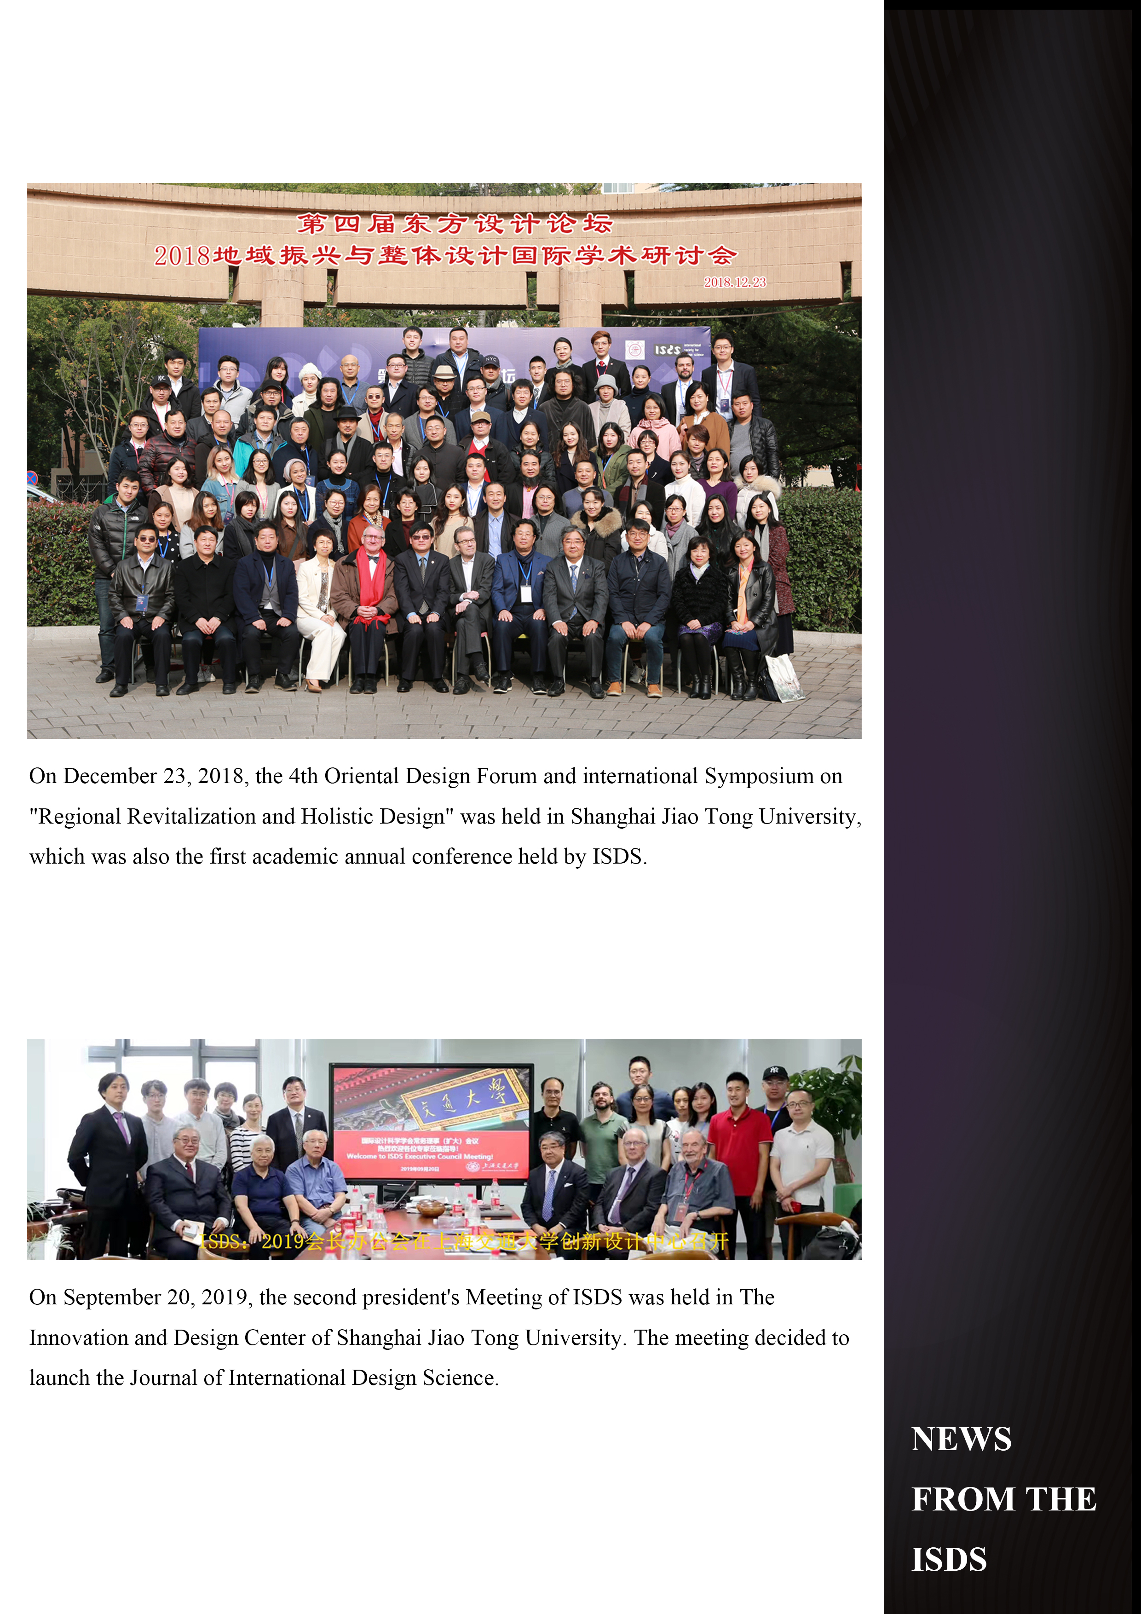
Figure 1. Figure
The thesis is generally composed of title, text description, figure and table.

TEXT
The thesis is generally composed of title, text description, figure and table.
The thesis is generally composed of title, text description, figure and table.

REFERENCES
Fei, X. T. (1999). Challenges of Chinese Culture in the New Century. Yan Huang Chun Qiu, 03: 2-4.
Ji, X. L. (2008). Three Topics of Oriental Culture. Xin Xiang Pin Lun, 01:52-55.
Liu, J. L. (2010). On the Cultivation of Cultural Consciousness. Journal of Liaoning Technical University (Social Science Edition), 03: 233-235.
Peng, X. Y., Liu, Y. D. (1999). Cultural Relativism and the Construction of Oriental Aesthetics. Tianjin Social Science, 05:79-83
Zhou, J. Y. (1985). Summary of Chinese Painting Theories. Nanjing: Phoenix Fine Arts Publishing.
Zhou, W. Z. (2017). Re-discussion on Oriental Design: The Concept, Content and Research Significance of Oriental Design. China Ancient City, 09:4-10.
Zhou, W. Z. (2019). On Oriental Design (III): Analysis of Some Relations in the Studies on Oriental Design. China Ancient City, 01:9-16.
Zong, B. H. (2013). Aesthetics and Art. Shanghai: ECNUP.

Name: Title, Major, Organization, City, Country.
Email:<sample@sample.sample>

